Gabrielle Grigoriadis
IWED5112w
ST10303533
PART 1 : POE

Saddle Sheek


Table of Contents
- Motivation to developing a website …………………………3
- List of resources ………………………………………………4-5
- User persona ………………………………………………….6
- Folder structure ……………………………………………….7
- Sitemap ………………………………………………………..8
- References ……………………………………………………9

Motivation for developing a website
Building a website is important for businesses that want to build trust, reach more people, and make the consumer experience as smooth as possible in today's digital world. A website is the main part of a brand's online presence. It gives them complete control over design, messaging, and the customer journey. This is not possible with platforms like Facebook or Instagram because of the way their algorithms work (Kaplan, 2020). A website gives Saddle Sheek, a niche equestrian business, a chance to show off its high-quality, fashionable, and configurable items in a way that appeals to its target market and makes them want to buy them. It makes people more professional and trustworthy since people are more willing to buy from brands with well-designed websites (Kaplan, 2020). It also lets people browse and buy at any time of day or night. The website will also make the customer journey easier, from finding out about the business and exploring products to customising them and checking out. This will improve the user experience and boost conversions (Taariq Motara, 2023). It is important because it lets Saddle Sheek show off its unique selling point of custom-designed equestrian clothing and build its community-based identity through stories like rider specs and branded storytelling. A website also opens up more marketing options, such as being seen by search engines and being part of digital campaigns (Taariq Motara, 2023). This helps the business grow and stay in business for a long time. So, building a website is a smart investment that will make Saddle Sheek look like a respectable, modern, and competitive brand in the equestrian sector while also increasing sales and engagement (Kaplan, 2020).

List of resources

Pictures

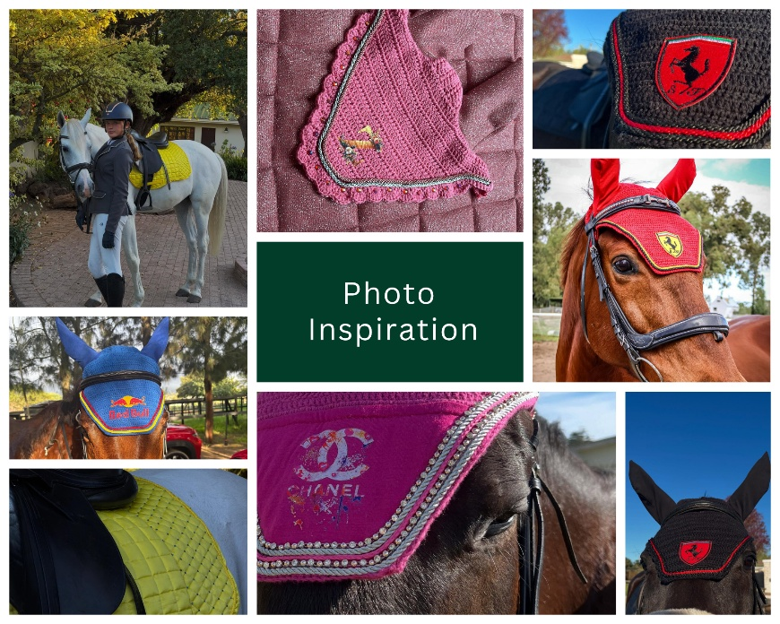

Video

Logo


Icons

Google Form
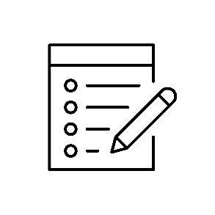

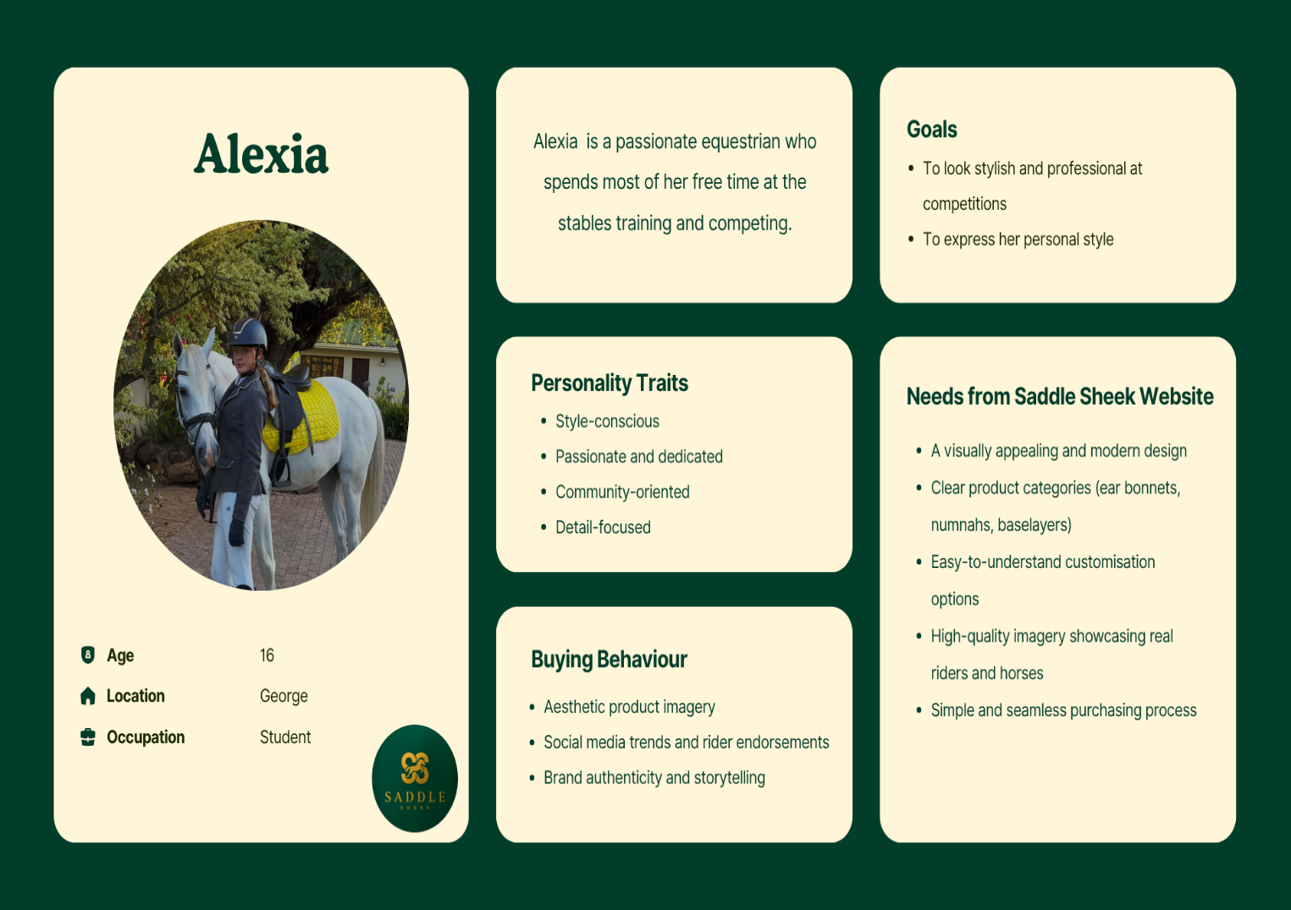
User Persona

Folder Structure
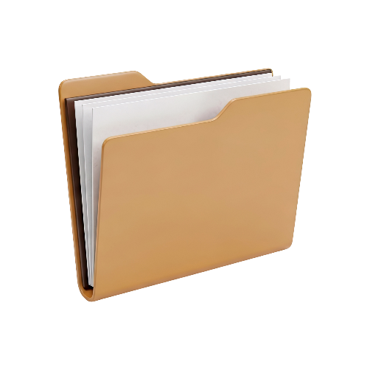

POE FOLDER
Styled by Saddle Sheek

Home.html About.html Customise Shop Checkout

Sitemap
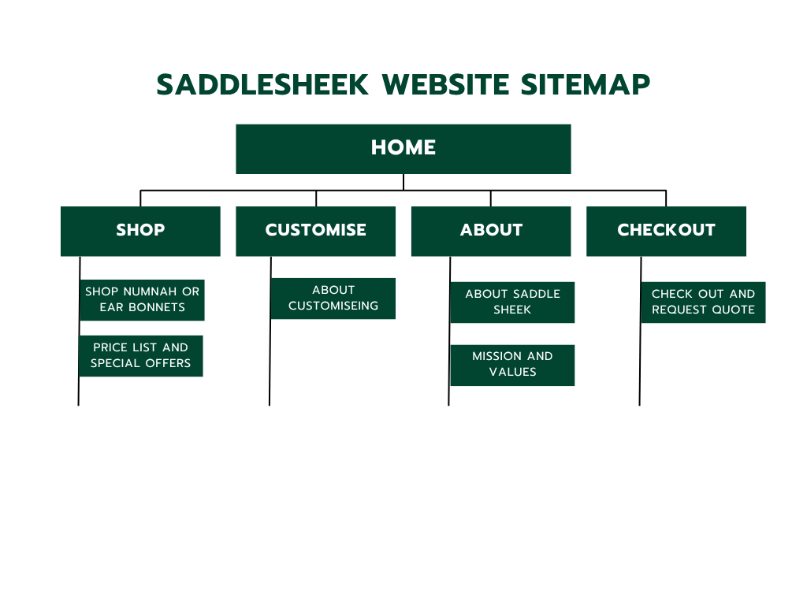

Resources
Taariq Motara. 2023. 10 Reasons Why All Businesses Need a Website. [online]. Available at: https://1up-digital.co.za/10-reasons-why-all-businesses-need-a-website/ [Accessed 4th of April]
Kaplan, K. 2020. Council Post: Why Every Business Needs A Website. [online]. Available at: https://www.forbes.com/councils/theyec/2020/02/03/why-every-business-needs-a-website/ [Accessed 4th of April]

